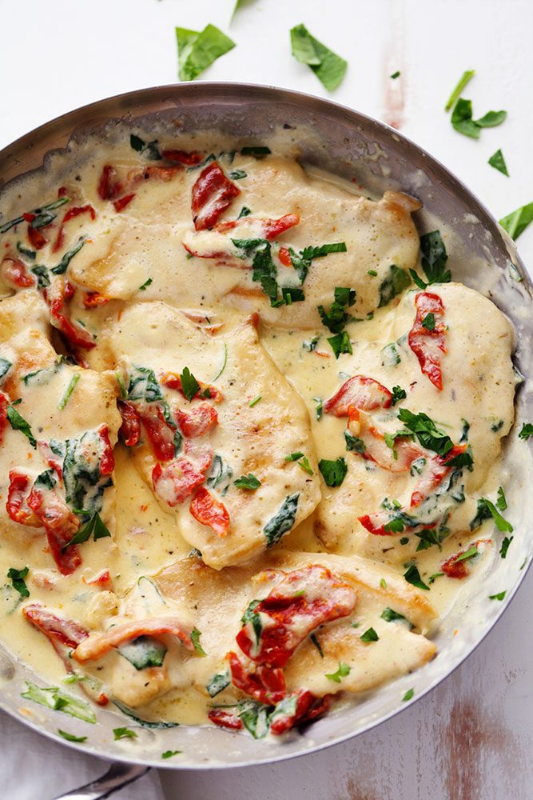
Creamy Tuscan Garlic Chicken
Prep Time 10 min Cook Time 15 min
4 Servings
Ingredients
1½ pounds boneless skinless chicken breasts
2 Tbsp olive oil
1 cup heavy cream
½ cup chicken broth
1 tsp garlic powder
1 tsp Italian seasoning
½ cup parmesan cheese
1 cup spinach, chopped
½ cup sun dried tomatoes
Directions
- In a large skillet add olive oil and cook the chicken on medium high heat for 5-6 minutes on each side or until brown on each side and cooked until no longer pink in center. Remove chicken and set aside on a plate.
- Add the heavy cream, chicken broth, garlic powder, Italian seasoning, and parmesan cheese. Whisk over medium high heat until it starts to thicken. Add the spinach and sundried tomatoes and let it simmer until the spinach starts to wilt. Add the chicken back to the pan and serve over pasta if desired.

Notes
If you are serving over pasta and like it saucy, double the sauce.

